**USER’S**

**MANUAL**

ELSA 1.0

**

**Ver: 1.0**

September 9, 2016

**Revision History**

This document as an explanation of ELSA 1.0

|  |  |  |  |
| --- | --- | --- | --- |
| Revision Number | Revision  Date | Summary of Changes | Author |
| 0 | 2016/09/09 | * Initial Version | Yudy Chen |

Index

1 Preface 7

Conventions 8

Actions 8

Icons 8

2 Introduction 9

3 Preparing the Installation 11

3.1 System Requirements 12

3.2 System Components 12

4 Install ELSA Web Management System 14

4.1 Installation 15

4.1.1 Installation Files 15

4.1.2 Processes 16

4.1.3 Installation Notes 20

5 Run ELSA Web Management System 21

5.1 Startup 22

5.2 Login to System 23

5.3 Change Language 23

5.4 Check Points after Starting Web 24

6 Devices management 27

6.1 General 28

6.1.1 Association 28

6.1.2 Deassociation 30

6.1.3 Push 30

6.1.4 Image Push 30

6.1.5 Show Barcode 31

6.1.6 Sync Association to PostgreSQL 31

6.1.7 Change wake-up mode 32

6.2 Advance 32

6.2.1 Remove  32

6.2.2 Query 32

6.2.3 Reboot 33

6.2.4 Setting Battery Threshold 33

6.2.5 Import Association 34

6.2.6 Show Tag’s Info 34

6.2.7 Show Tag’s History  35

7 Using Mobile Computer for Managing Tag 36

8 Manage Inventory 38

8.1 Insert inventory 39

8.1.1 Adding new product 39

8.1.2 Importing inventory 40

8.2 Edit Inventory 41

8.3 Remove Inventory 42

8.4 Backup to File 42

8.5 Associated Tag to Product 42

9 Manage Layouts 44

45

45

9.1 Associate Layout to Profile 46

9.2 Deassociate Layout to Profile 46

9.3 Add New Layout 47

9.4 Edit Layout 47

9.5 Generate Layout Preview 48

9.6 Remove Layout 48

9.7 Backup Layout Profile 48

9.8 Import Layout Profile 48

9.9 Remove Selected Profile 48

10 System Overview 49

10.1 General 50

10.1.1 Access Point Information 50

10.1.2 Network Summary 50

10.2 Advance 51

10.2.1 Path Information 51

10.2.2 Log 51

11 Maintenance 52

11.1 System Commands 53

11.2 Database Backup 53

11.3 Tag Behaviour 54

11.4 Email Settings for Report 54

11.5 Access Point Settings 54

11.6 Settings 55

12 Job Status 56

12.1 General 57

12.2 Advance 57

12.2.1 Retry Failed Job(s) 57

13 Auto Retry for Failed Job 58

14 Email Report and Notifications 60

15 Panel Explanation 62

16 User Management and Privilege 64

17 Pre-Processor (PP) 66

18 Appendix 68

18.1 Manually Restore Database from Backups 69

18.2 Database is locked 70

18.3 Contact Information 71

# 

# Preface

## Conventions

This manual uses the following conventions:

“AP” refers to Access Point

“RT” refers to Router

“ED” refers to End Device or tag

## Actions

Some actions are the same for different steps on this document and will be explained below.

1. Check the item(s). This action is used to check the item(s) for being managed.

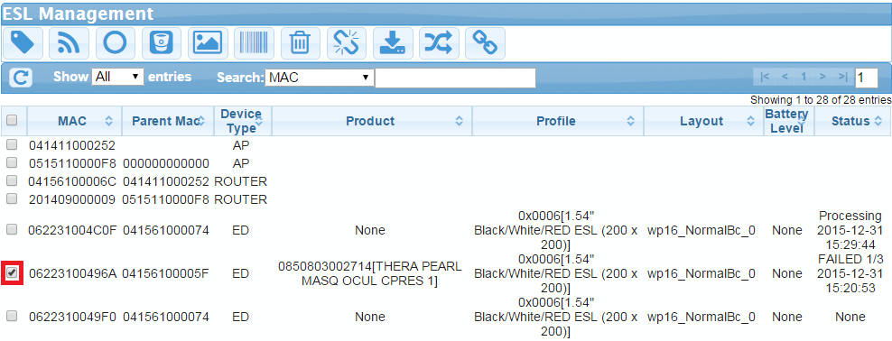

1. Confirm the action. Some actions need to be confirmed during the operation and the confirmation box like below will appear.

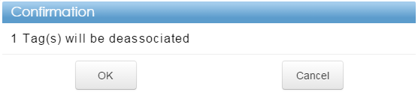

## Icons

Some pages or actions can only be accessed or run by Admin and or Super Admin (SA) user group. The items will be remarked with the icon below

 Admin

 Super Admin (SA)

# Introduction

Introduction is here

General description of ELSA

AP / RT/ ED blah blah

Application Architecture

-- Image Creator

PP / Layout description

Customized part if any

# Preparing the Installation

## System Requirements

* 1 gigahertz (GHz) or faster x86-64
* 2 gigabytes (GB) RAM
* 2 gigabytes (GB) available hard disk
* Windows 7 (64 bit) operating system
* PostgreSQL 8.3
* Google Chrome web browser

# Install ELSA Web Management System

## Installation

### Installation Files

ELSA 1.0 web management system comes with two separate installation files based on the purposes.

1. Basic installation file: 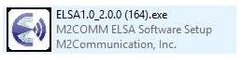

It contains functionality of devices management. The numbers describe ELSA version, major release version and minor release version. In this example 1.0 refers to ELSA 1.0. 2.0.0 refers to major version of the ELSA 1.0 is 2.0.0 and 164 refers the major version of 2.0.0.

1. Customization file (per customer): 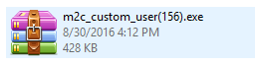

It contains customization based on customer needed (layout, settings, etc) and the file name starts with m2c_custom

|  |  |
| --- | --- |
| ☝  NOTE | *Customization file can be installed by two ways:*   * *Put m2c_custom.exe on the same directory with ESLWebSystem_Setup.exe and the installation will continue to run this file* * *Run m2c_custom.exe independently by double click it, firstly need to stop ELSA Web Management System* |

### Processes

ELSA 1.0 web management system takes some steps for installation. Please follow the instruction below to finish the installation.

In this process, simply click next to process the installation.

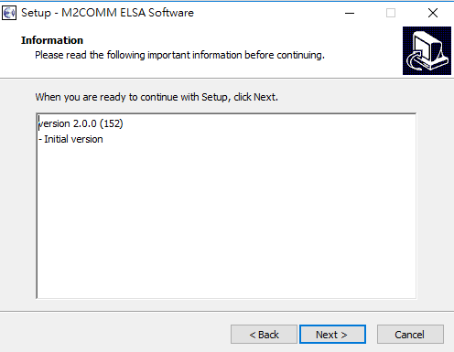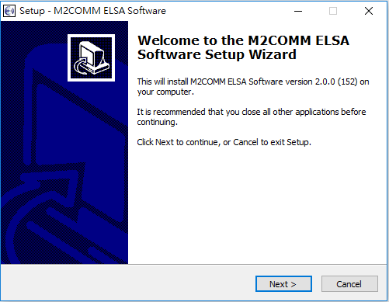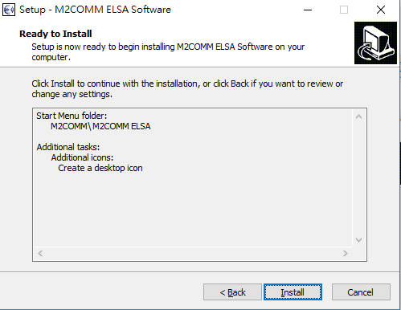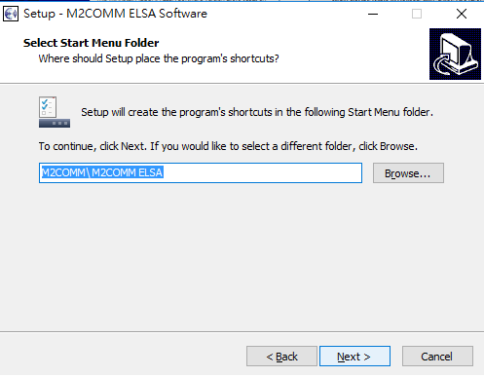

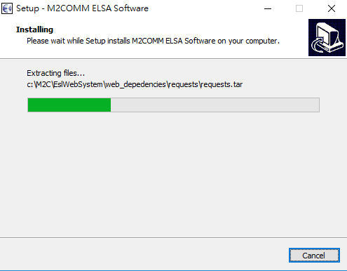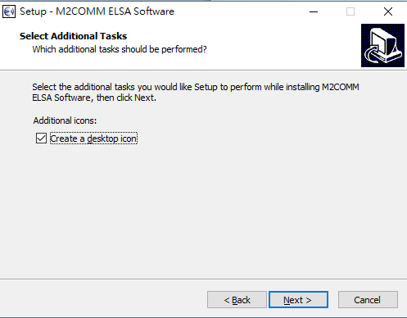

Continue click next for Python installation

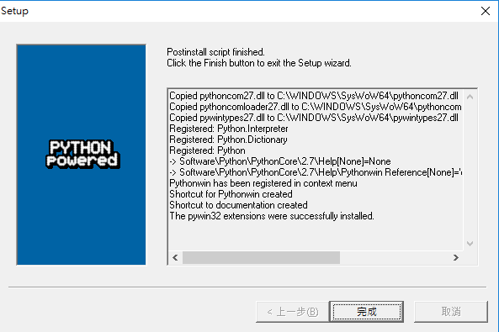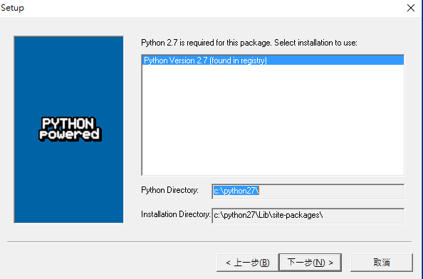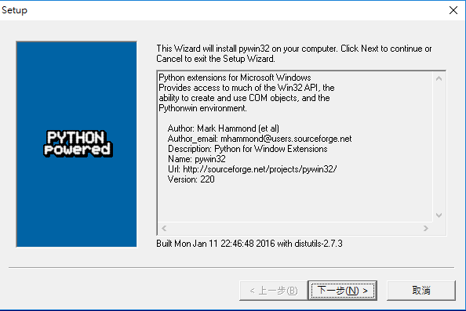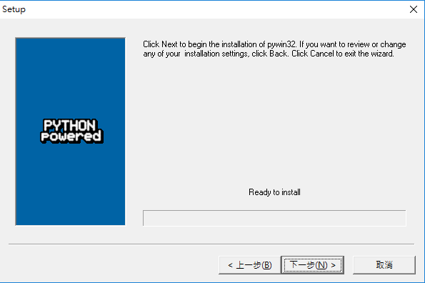=

Click “Next” to continue.

Pywin32 installation

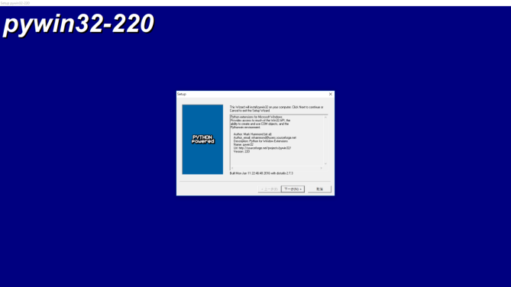

WxPython installation

Please keep default settings for wxPython installation and keep click next

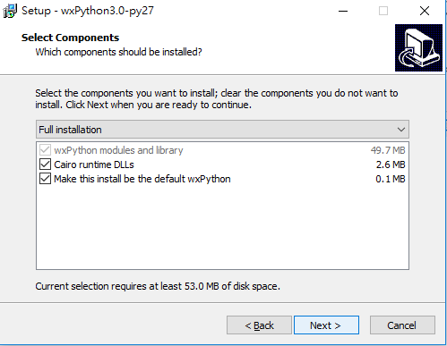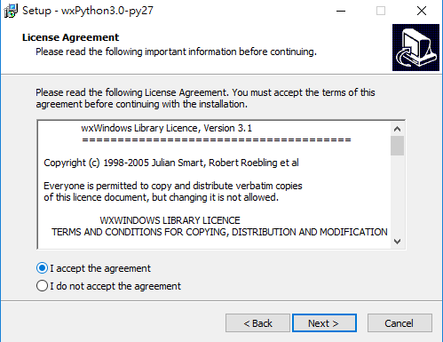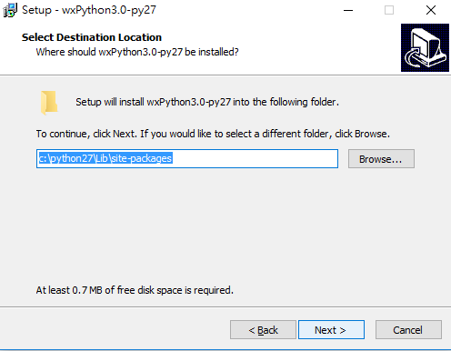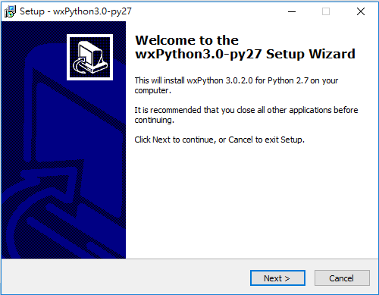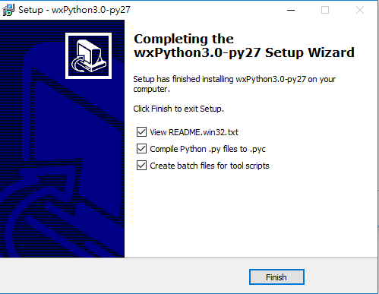

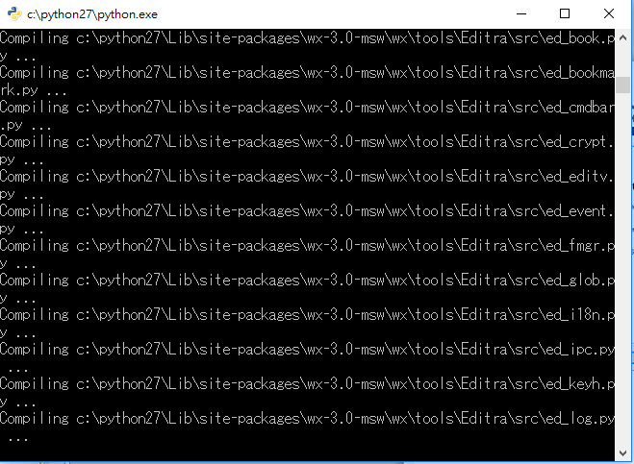Some Python modules are needed and windows like below will appear. Just wait until all modules are installed.

If customization file is included on the same directory with basic installation file, the window like below will appear to continue the installation otherwise the installation is finish.

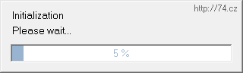

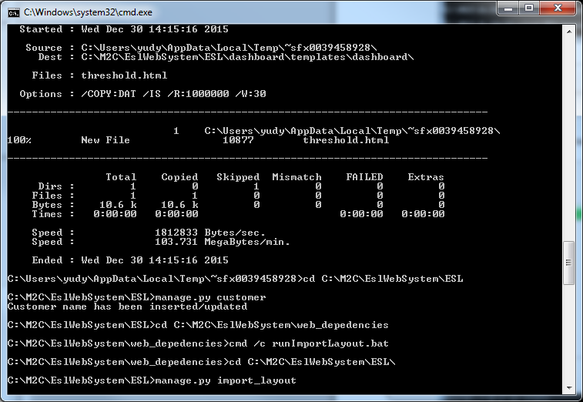

The installation is finish when window like below appears

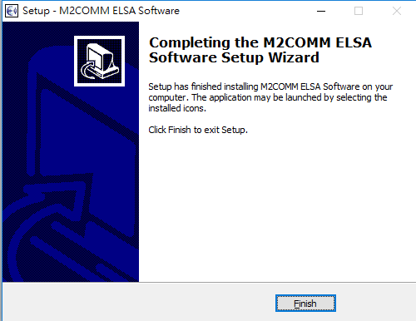

### Installation Notes

If something wrong after the installation, database backup is located at “C:\M2C\” which can be used to restore previous data content.

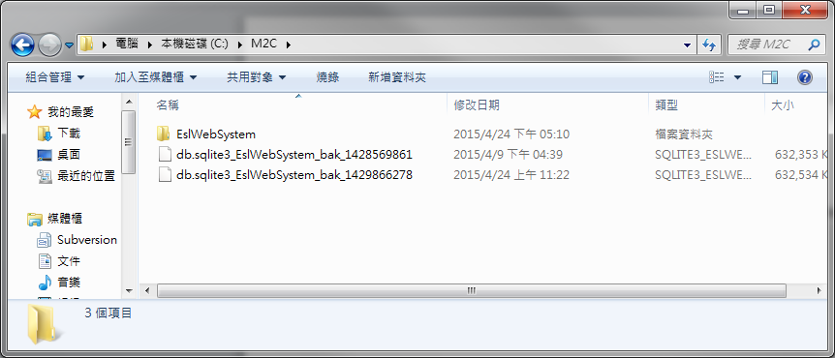

# Run ELSA Web Management System

## Startup

Follow the steps below to run ELSA web management system

1. Double click icon M2C ELSA Web System 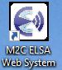 on the desktop.
2. If there is no AP on the database, you will be asking to use default IP or not. Default IP is 192.168.2.1.

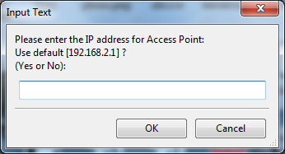

1. If your AP uses different IP address, type the IP address in the box below.

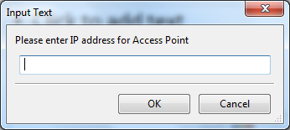

1. When ELSA web management system is active, you can see the icon will appear on the taskbar.

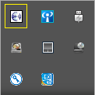

1. Right click the mouse to see the menu.

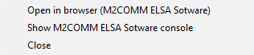

## Login to System

To use the system you need to access ELSA web management system by doing:

1. Right click the taskbar menu above and click “Open in browser (M@2COMM ELSA Software)
2. Or, use web browser and go to [http://127.0.0.1:88/](http://127.0.0.1:88/dashboard)
3. Page like below will appear.



1. Login with the registered username and password.

|  |  |
| --- | --- |
| ☝  NOTE | *ELSA web management system work on Google Chrome web browser.* |

## Change Language

ELSA web management system available on different languages. You can choose the language based on your preference by selecting the options at the top right corner of the page.



## Check Points after Starting Web

After starting the web, please check the following items to see if the web has been started successfully.

1. Make sure console doesn’t show dead process like below

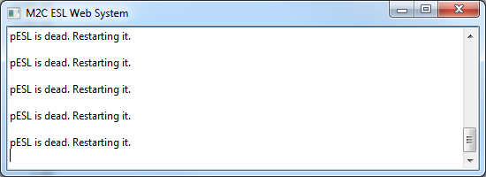

1. Check “Access Point information” on dashboard page. If AP information appears like below, it means the system runs properly.



Otherwise it means connection to AP is lost. It can be due to wrong IP address, link down (physically, blocked by firewall, etc).

|  |  |
| --- | --- |
| ☝  NOTE | *Try to fix:*   * *Check IP address is set correctly.* * *Check network connection to AP is good.* |

1. If web browser show information like below, it means web has some issues.

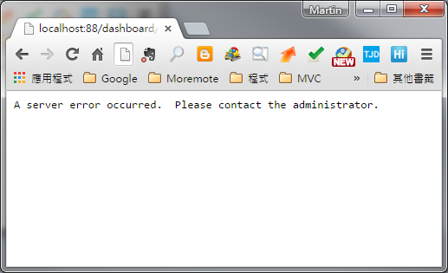

|  |  |
| --- | --- |
| ☝  NOTE | *Contact system admin.* |

1. Web installation brings default profiles; therefore the layout page should contain list of profiles like the image below. 

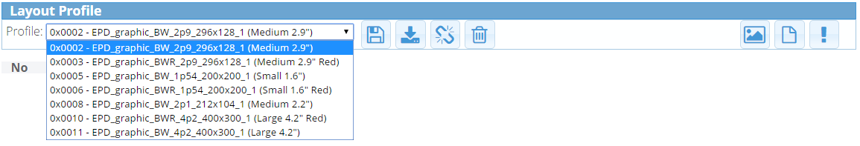

1. You also need to check that ELSA web management system contains 1 default product like the image below in inventory page.

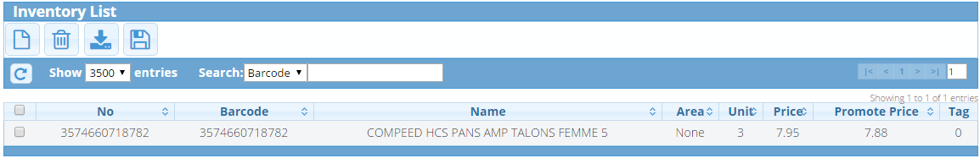

1. You also need to check the version of web is correct from dashboard page.

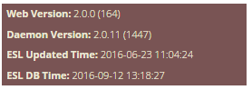

# Devices management

ELSA web management system provides you some functions to manage the system including devices management. To manage the devices (AP, router, tag) you need to go to “ESL Management” page.

In this topic, we split our discussion into two parts, general and advance.

## General

Here, in general part we discuss about the actions related for daily operations.

### Association

The main functionality of tag is to show the information; therefore we need to associate the product into it. You can follow the steps below to associate the product

1. Double click one of the tags from the list. Only “TAG” can be associated.

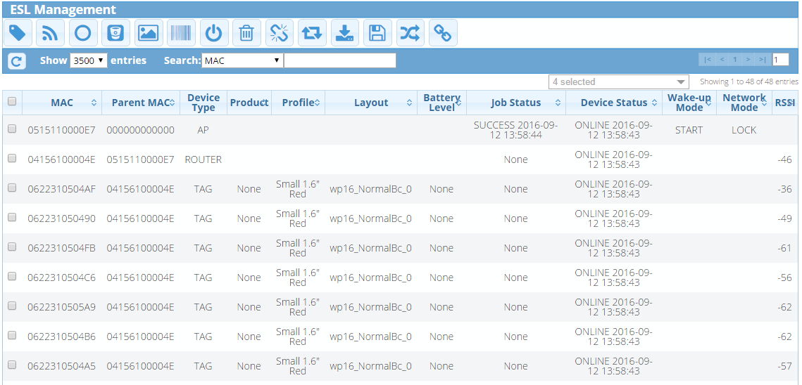

1. The window like below will appear. Click on the pencil icon to choose the product.

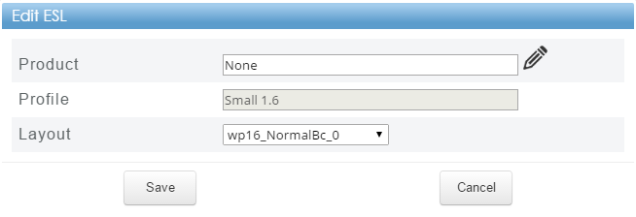

1. After the list of product like below appears, you can choose the product and click “Select”.

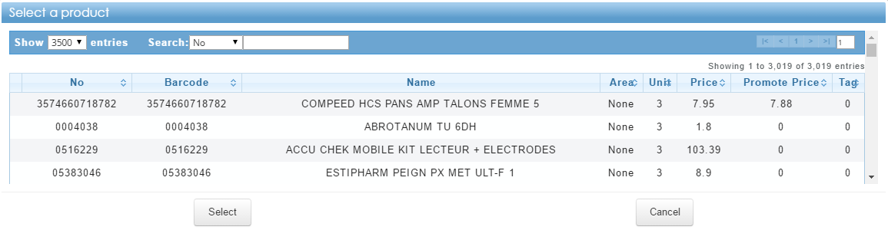

1. After choosing the product, the window like below will appear. You also can change the layout in this step. If everything has been chosen correctly you can click “Save” and the tag will update its information with the newest data.

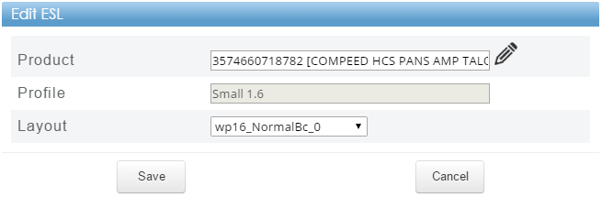

1. From the list, you can notice the product has been changed

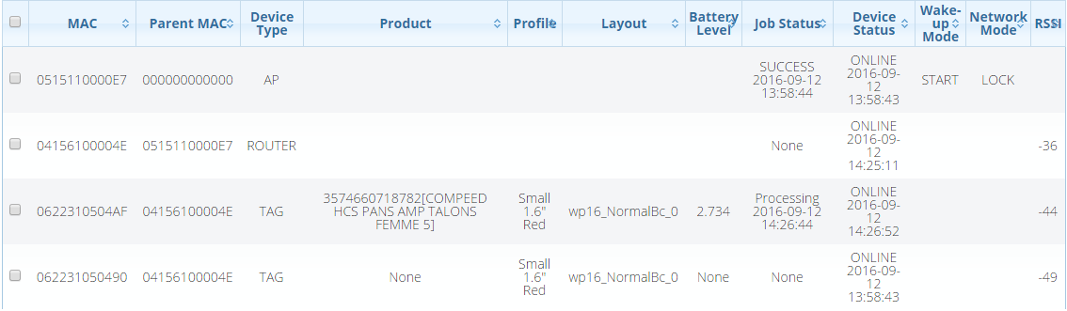

1. You should see newest information on device (tag) after one minute.

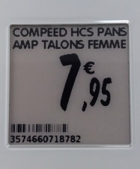

### Deassociation

When tag is not used to show the information, you can deassociate it from product. This will shut down the tag for saving the battery. To deassociate the product you can follow the steps below

1. Check the item(s) that will be deassociated then click icon 
2. Click “OK” on the confirmation.
3. As a result, you can see the product info will be “None”.

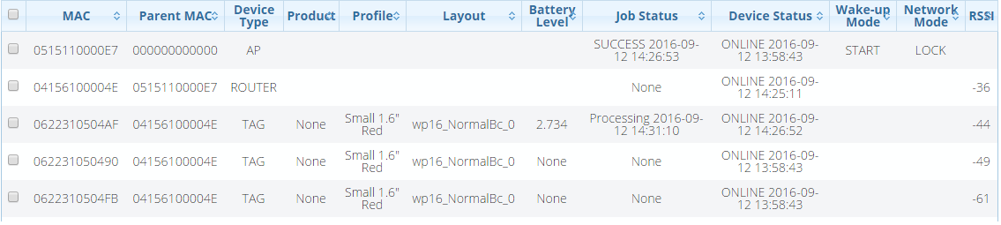

1. And from the tag (device) itself, it will be shut down and show the barcode.

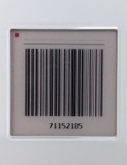

### Push

Another function that you can use is “Push” the tag with the existing data. This is used to make the tag shows the needed information if current image on the tag itself doesn’t show the needed information (probably due to “image push” or “show barcode” functions that we may discuss this later).

To push the tag, simply check the items that want to be pushed then click icon 

### Image Push

Image push is used for showing the image to tags. Follow the steps below to do image push

1. Check the items that want to be pushed then click icon 
2. The window below will appear. Choose the image file and the preview will appear

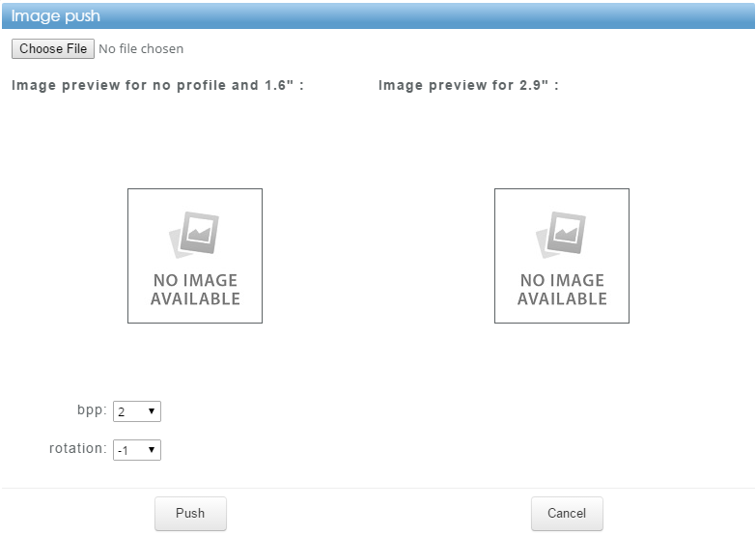

|  |  |
| --- | --- |
| ☝  NOTE | *Parameters for bpp:*   * *1 for tag with black and white profile.* * *2 for tag with black, white and red profile*   *bpp can only be used by admin or SA* |

### Show Barcode

Show barcode is used for showing the tag’s barcode at device. This is useful to make scanning MAC address easier than scanning the sticker on the bottom of device.

For showing the barcode, simply check the items that want to be shown barcode then click icon 

### Sync Association to PostgreSQL

PostgreSQL is used as a bridge between ELSA web management system and customer for association information. This (sync) action is used to sync ELSA web management system association information to PostgreSQL database.

To sync the data, click icon  and after sync is done, the window like below will appear to show how many items are synced. Only items with changed association will be synced.

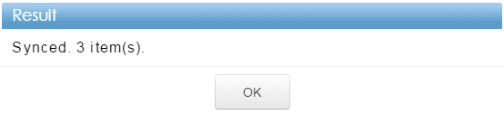

### Change wake-up mode

When you see the tags are shutdown. You can turn it on by using wake-up function. The function can be triggered by check the “AP” and click icon 

|  |  |
| --- | --- |
| ☝  NOTE | *Change wake-up mode will change mode into opposite mode. If current mode is STOP, this will change to START and vice versa* |

## Advance

Here, in advance part we discuss about the actions related device maintenance.

### Remove

Sometimes you need to remove the devices from network. This is probably caused by some reasons such as broken devices or unnecessary devices.

You can follow the steps below to remove the deives

1. Check the item(s) that will be removed then click icon 
2. Click “OK” on the confirmation.

### Query

Query is used for ………….

To query the devices, check the item(s) that will be queried then click icon 

|  |  |
| --- | --- |
| ☝  NOTE | *Device status of queried devices will be OFFLINE, and return back to ONLINE later once web receives link report from daemon.* |

### Reboot

Reboot is used for ……………..

To reboot the devices, check the item(s) that will be rebooted then click icon 

|  |  |
| --- | --- |
| ☝  NOTE | *Device status of rebooted devices will be OFFLINE, and return back to ONLINE later once web receives link report from daemon.* |

### Setting Battery Threshold

It is important to easily notice tags with low battery voltage. Here, you can set the threshold for low battery.

Battery level of each tag is lower than the value set in battery threshold will be shown in red color.

To set the low battery threshold,

1. click icon  and the window like below will appear.

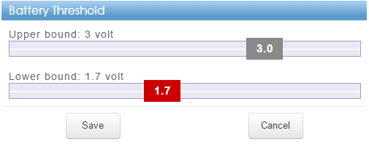

1. Set needed lower bound and click “Save” after finish.

### Import Association

Sometimes you already have association list and to speed up the association process, you can use import association function.

You can follow the steps below to import association data.

1. Click icon  and dialog box like below will appear.

* Choose the file by clicking “Choose File”. The file should be on CSV format.
* Click “Import” when file is ready.

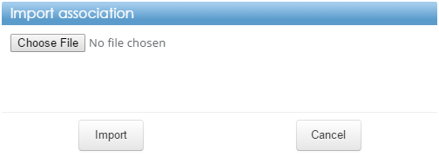

#### The format of this CSV file is “Action, MAC, barcode”. The example is shown below.

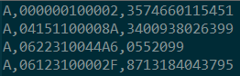

* Action can be A for Association, D for Deassociation or R for Remove.

### Show Tag’s Info

Not all information shown on the device lists. For detail information, you can hover your mouse on the device lists

Then the box like below will appear

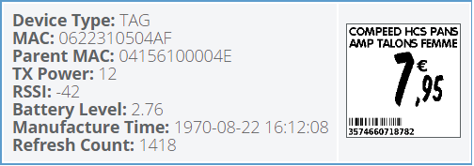

### Show Tag’s History

For debugging usage, you can check device history by clicking one tag and click on the bottom right corner. Then tag’s history will be shown on small window like below.

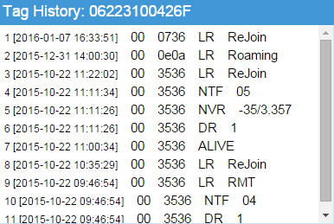

# Using Mobile Computer for Managing Tag

The actions in this section are on the “BC” page.

Follow the instruction below to access “BC” page:

1. On the “ESL Management” page, Click icon  or go to [http://”server_ip”:88/en/esl/bc](NULL). The window like below will appear



Number of failed job

List of action

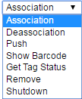 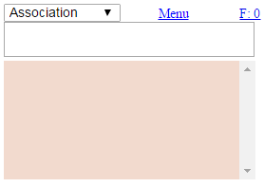

Action’s log

Input box for scanning

|  |  |
| --- | --- |
| ☝  NOTE | * *Scan MAC then barcode for association* * *Only scan MAC for action other than association* * *Get Tag Status (information about product, status and battery level of tag).* * *Remove can be done by admin or SA* * *Explanation about retry failed job(s) is* [*here*](#_Retry_Failed_Job(s)) |

# Manage Inventory

After you know how to manage the devices, you need to know how to manage your inventory in ELSA 1.0 because the tags information comes from inventory.

The actions in this section are on the “Inventory” page.

## Insert inventory

You can add new inventory into the system by two ways

### Adding new product

1. Click Icon  and window like below will appear.

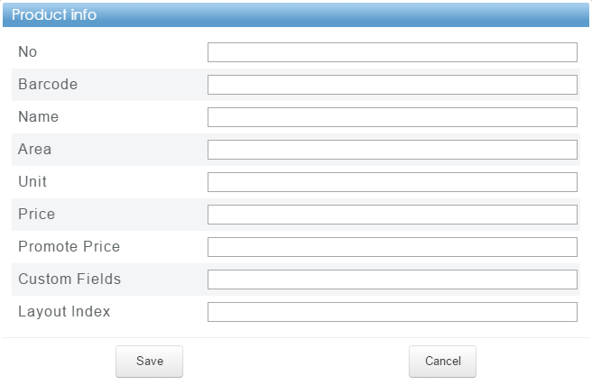

1. Input needed information then click “Save”.

|  |  |
| --- | --- |
| ☝  NOTE | * *No (number) can be duplicated on database but not for barcode* * *When you use “Layout Index” for this product, the tag associated with this product will use layout index associated to tag’s profile. We will discover this in “manage layouts” later* |

### Importing inventory

If you have a list of inventory, you can save the file with csv format and import it into ELSA web management system

Follow the steps below to import the inventory

1. Click icon  then the window like below will appear.

* Choose the file by clicking “Choose File”. The file should be on CSV format.
* Click “Import” when file is ready.

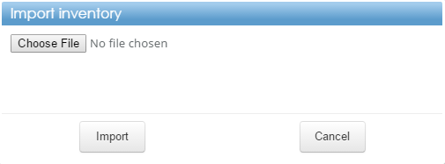

#### Below is the CSV format for importing product.



|  |  |
| --- | --- |
| ☝  NOTE | * *Layout here is “layout index” same like adding inventory above.* * *Action can be “M” which means modify or insert and “R” which is remove the inventory* * *Tag associated with modified product will be updated* * *Tag associated with removed product will be deassociated* |

## Edit Inventory

Sometimes you need to update the inventory. Follow the steps below to edit the inventory manually

1. Double click the product on the list. The window like below will appear.

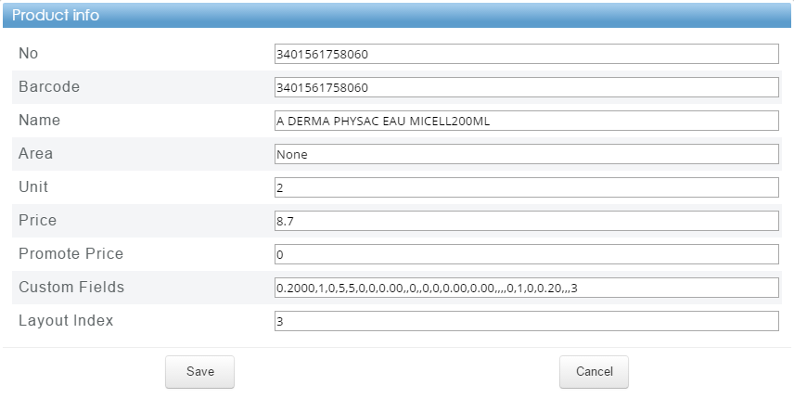

1. Edit needed information then click “Save”.
2. As a result, tags associated with this inventory will be updated.

|  |  |
| --- | --- |
| ☝  NOTE | *As mentioned above, by importing list of inventory you can also edit the inventory by placing “M” as an action following the information of changed inventory based on barcode* |

## Remove Inventory

When inventory is no longer be used, you can remove it from ELSA 1.0 web management system. Follow the steps below to remove the inventory

1. Check the item(s) that will be removed then click icon 
2. Click “OK” on the confirmation.

|  |  |
| --- | --- |
| ☝  NOTE | *As mentioned above, by importing list of inventory you can also remove the inventory by placing “R” as an action following the information of removed inventory based on barcode* |

## Backup to File

If you want to backup inventory data, you can use “backup to file” feature by clicking icon  and csv formatted file will be downloaded to local computer.

## Associated Tag to Product

If you want to check tags that associated to product, you can click column “Tag” on the inventory page. This column show the number of tags associated to the product.

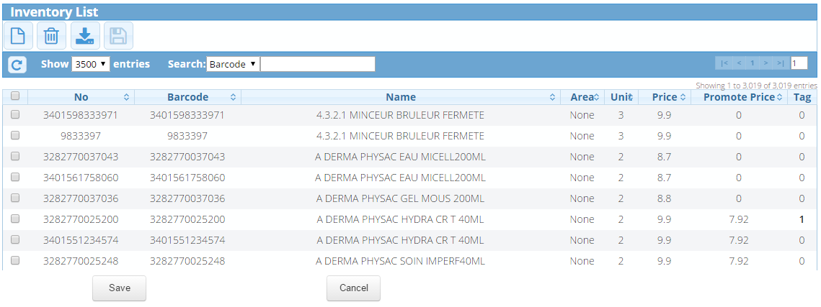

After you click the column “Tag”, the window like below will appear.

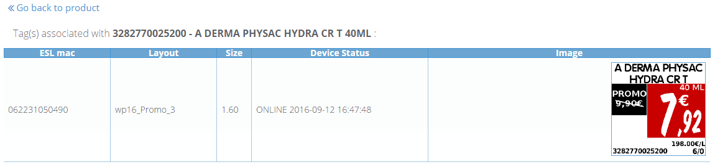

# Manage Layouts

Layout is really important part for tag. It defines the places of information in tag for instance where to put product’s name, what is the font-size to be used for price, etc. In this topic you will know how to manage the layout you want to use.

The actions in this section are on the “Layout Profile” page. 

## 

Collection of layouts

List of profiles

## 

List of associated layouts here

## Associate Layout to Profile

For using the layout, first you need to associate the layout into the profile. Follow the steps below to associate the layout to profile

1. Choose the profile from the list
2. Click icon  at specific layout
3. If adding the layout is success, the left side of image above will be looks like image below

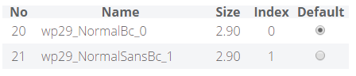

|  |  |
| --- | --- |
| ☝  NOTE | * *Do you still remember about “layout index” for product? The “layout index” refers to “Index” at the image above. Basically it just simply the order of layout association to profile* * *When you add layout, it will be added as a last index* * *You can change the index by dragging the layout to the targeted index* * *You can also set the layout as default layout for profile by click column “Default”* |

## Deassociate Layout to Profile

In case you associated wrong layout and you want to deassociate it from profile, you can do it by double click the layout in associated list.

You can also deassociate all layouts from profile by clicking icon 

## Add New Layout

You can add new layout by click the icon  then the window like below will appear

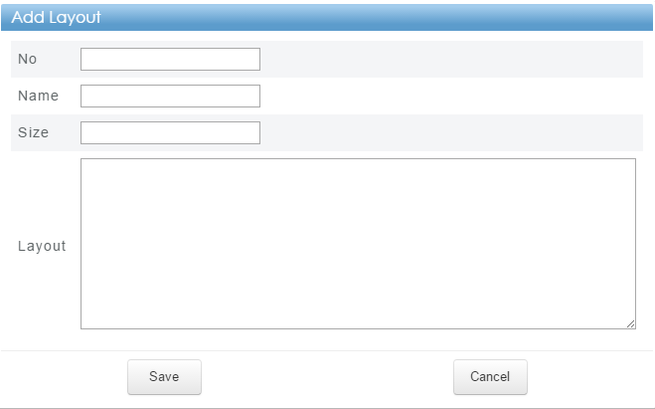

Input needed information and click “Save”

|  |  |
| --- | --- |
| ☝  NOTE | * *Layout is based on xml format* * *No and name cannot be duplicated* |

## Edit Layout

You can edit the layout by clicking icon  then the window like below will appear

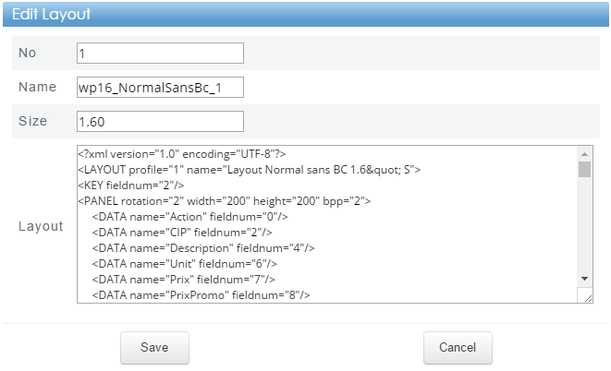

Edit the data and click “Save”

## Generate Layout Preview

If you don’t see the image under collection of layouts, you can generate the image preview by clicking icon 

## Remove Layout

If you want to remove unneeded layout, you can do it by clicking icon on the specific layout and confirm the confirmation.

You can also remove all layouts by clicking icon  and confirm the confirmation.

## Backup Layout Profile

If you want to back up the layouts and profiles including the associations, you can click icon  and zipped file will be downloaded into your computer.

## Import Layout Profile

You can also import the layout into the system by clicking icon  and window like below will appear

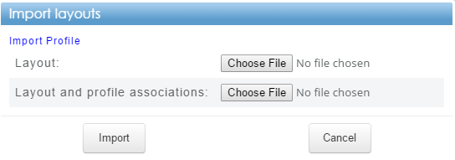

|  |  |
| --- | --- |
| ☝  NOTE | * *Click “Import Profile” to import profile* * *The input files are JSON file format* * *Same number or profile / layout will be updated* |

## Remove Selected Profile

You can also remove the selected profile by clicking icon . As a result, selectd profile will be removed from list of profiles

# System Overview

The actions in this section are on the “System Overview” page.

## General

### Access Point Information

In normal operation, connected access point is displayed like below.



Note:

1. *If there is no MAC shown on the information, it means AP is not connected with daemon*
2. *Sometimes firmware info is not shown but the status is connected. This is due to web gets the firmware info later after MAC information*

### Network Summary

It shows number of items on database (product, AP, router, tag, profile)

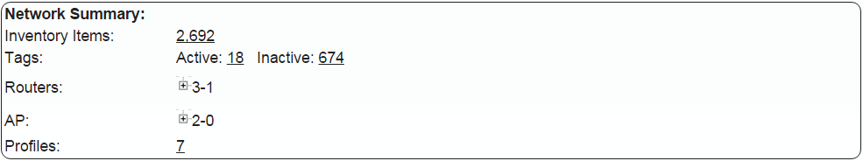

Note:

1. *Number of AP and router show active number followed by inactive number*
2. *Click sign + on AP or router for detail. Example is like picture below*

Active - Inactive

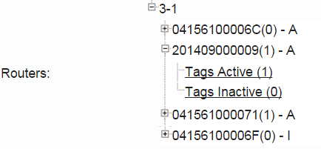

Number of Tag

MAC(tags join this router) – (A = Active; I = Inactive

## Advance

### Path Information

It shows the path information for database file log file and image creator

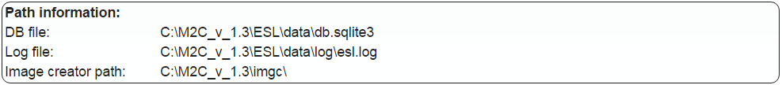

### Log

Here shows the system log (esl.log).

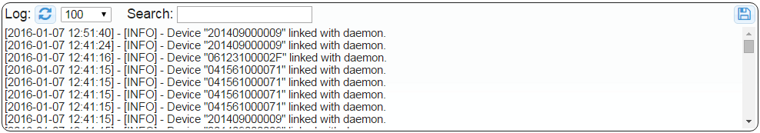

Note:

1. *Click icon*  *to retrieve logs from server.*
2.  *indicates maximum number of lines to show.*
3. *Type keyword on search box for searching on log.*
4. *Due to maximum showing is 2000 lines and logs are split into several files, click icon*  *to download the logs file for checking on local site.*

# Maintenance

The actions in this section are on the “Maintenance” page. 

For accessing this page, click icon  at “System Overview” page under “Maintenance” section.

## System Commands



Actions can be run in system commands section which are:

*  for showing barcode to all tags
*  for rebooting all tags
*  for shutting down all tags
*  for sync database between daemon and web
*  for shrink db.sqlite3 (Web ESL Management System database)

## Database Backup

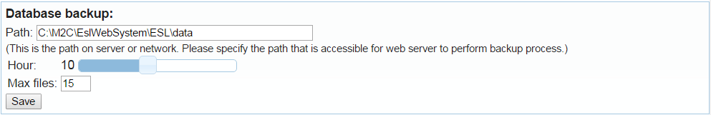

Input needed information and click save button.

Note:

1. *Path: location for database backup*
2. *Hour: time backup will be performed*
3. *Max files: maximum number of backup files*

## Tag Behaviour



Actions can be run in this section related to tag:

* Refresh hour: this is the time to perform refreshing tag display

## Email Settings for Report

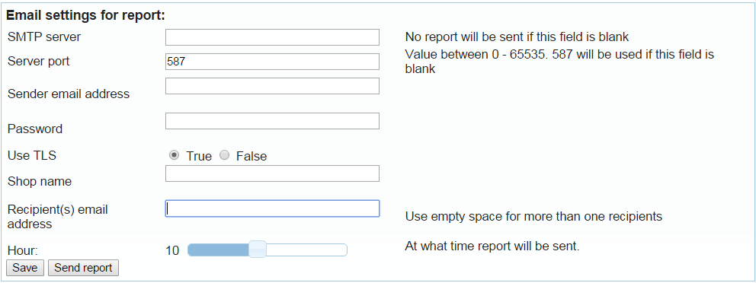

1. Input needed information then click save button.
2. After save, click “send report” for testing configuration is working properly or not.

## Access Point Settings

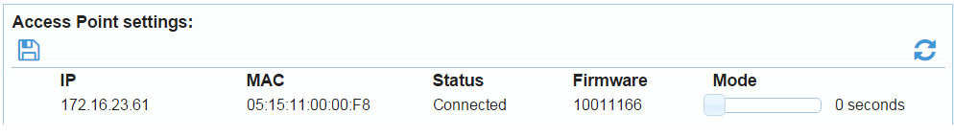

1. Set “Mode” by dragging 
2. Click icon 

## Settings

The actions in this section are on the “settings” page. 

For accessing this page, click icon  at “System Overview” page under “Maintenance” section.



Deassociation method is how to treat deassociation.

Other settings may be included in this page depends on customer customization.

# Job Status

To check job status, click  on the bottom of every page (except “BC” page) then panel like below will appear.



## General

1. “View past” is for limit how many days job want to be shown
2. Click date for detail of job on that day
3. When date is clicked, it will show list of batches and click the batch for showing detail of jobs like below

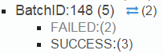 Which means Batch ID number is 148, has 5 jobs (2 failed and 3 success).

1. Click the status (FAILED or SUCCESS) for showing the job then it will show like below. Here, it shows the detail of jobs

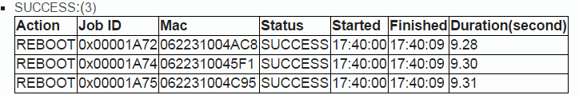

## Advance

### Retry Failed Job(s)

1.  is the number of failed job on that day. Click icon  to retry failed job and click “OK” on the confirmation.
2. Failed jobs will be retried are the jobs after tag’s refresh hour until the retried is executed.
3. For retry on date, only latest unsuccessful job on tag’s will be retried
4. For retry on batch, all unsuccessful on batch will be retried

# Auto Retry for Failed Job

ESL Web Management System has a feature which is auto retry failed job on current day. The behaviors of auto retry described [here](#_Retry_Failed_Job(s)).

Some information about auto retry:

* Time gap for auto retry is 15 minutes (0, 15, 30, 45).
* Settings for auto retry defined inside C:\M2C\EslWebSystem\ESL\ELS\config.json
* Maximum retry per tag is defined at “max_auto_retry_time”. Set to 0 for disable auto retry.
* Per batch retry is defined at “max_auto_retry_item”. Set to 0 to do one auto retry for all unsuccessful job.
* Skipped job status for retry : success, queried, path_not_found, Retry_x, AUTO_RETRY_x
* Status of job is AUTO_RETRY_x
* x = retry batch id (new batch id for retry)
* Failed tag’s status for auto retry is FAILED x/y
* x, failed time for auto retry
* y, max auto retry
* After maximum retry, tag status will be “UNREACHABLE”
* “UNREACHABLE” tag’s will be notified by email as an alert
* After tag re-join (web get LR), “UNREACHABLE” will be “A: Notify LR xxx”
* “A: Notify LR xxx”, will be notified as Notify LR. After emailed, the status will become None
* Notify LR means tag is alive from unreachable

# Email Report and Notifications

ESL Web Management System has a feature for daily email report and notification. Email setting can be found here.

* Currently notification supports:
* Unreachable tag due to auto retry
* Link report after unreachable.
* The email notification is sent before auto retry.

# Panel Explanation

This section will explain ESL Web Management System panel which are used by some pages.



* Checkbox  on the table header is for check all items.
* Icon  is for revert current selection.
*  is for setting maximum item to be shown.
*  is for searching function (parameter and keyword).

Note:

Special cases are used under “ESL Management” page which are:

1. *Can search by encoded MAC (using scanner) for MAC and Parent Mac*
2. *Searching by “Battery Level” can also use symbol including: <, >, <=, >=, =, -, no bat, low bat.* 
   1. *No bat indicates there is not enough battery to refresh the display and on the Battery Level column, it will display  icon instead of number*
   2. *Low bat indicates battery level is below the “Lower Bound” set on battery threshold and web will display red color on “Battery Level” column*
3. *Parameter “Empty Product” to search tags associated with product without name*
4. *Parameter “No Product” to search tags without products association*

*  table pagination to show current page number, number of entries shown on table, jump to specific page.
* Icon  is used for sorting the table.

# User Management and Privilege

ESL Web Management System has a feature to change user’s password, adding and removing user. Follow below instructions for user administration

1. Go to “Maintenance” page.
2. At “Change admin password”, click “here”. 



1. It will redirect the page to “admin” page.

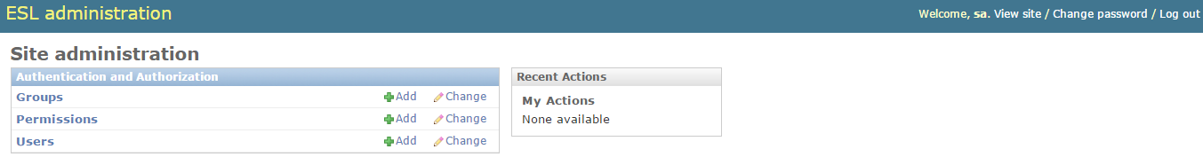

1. Currently, “Permissions” setting is not used.
2. Default configuration will have three groups which are “M2C Admin”, “M2C SA” and “user”. Notes are written here about groups.

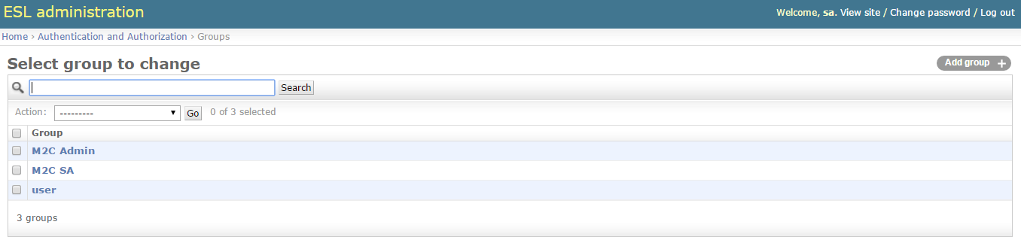

1. Default configuration will have three users which are “admin”, “sa” and customer specific user.

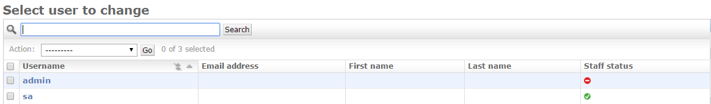

# Pre-Processor (PP)

The main role of PP (pre-processor) is to get customer product information to web. As every customers may have different schema for their products, it is important that PP deals with customer’s data and arrange them into the form that web can understand them.

Furthermore, due to the complexity of customer’s application, there will be different PPs for different customers. So one PP for one customer application, each PP will only process a certain schema for a certain customer.

**Overview:**

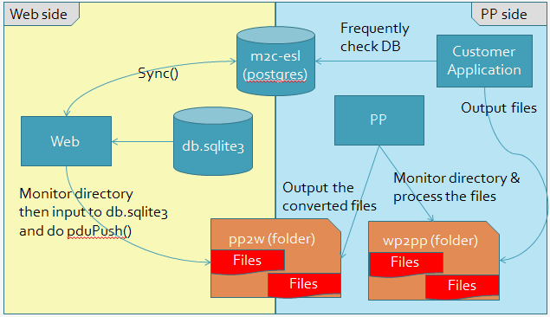

Basically, there are two stages that web involved interaction with pp.

Stage I:

At this stage, the main task for web is to sync database from web to customer database. On the other words, tags association information from web is synced to customer database.

Stage II:

At some certain conditions, either by manually or automatically triggered, customer application will generate a csv or ctrl file to web. This csv file contains a list of products that existed at customer side. And for ctrl file contains action for tags (association, deassociation, remove). Then web will update them into web’s database.

The format of CSV file is described here

The format of ctrl file is described here

# Appendix

## Manually Restore Database from Backups

Database can be restored from the backups if something goes wrong with the current status. Below are the steps to restore the database.

1. Using Windows explorer to go to database backup location which has been set here.

(default: C:\M2C\EslWebSystem\ESL\data)

1. Close the ESL Web management system.
2. Rename the file “C:\M2C\EslWebSystem\ESL\data\db.sqlite3” to whatever name you like.
3. Pick a database backup file you’d like to restore, and change its name to “db.sqlite3”
4. Double click “run_after_copy_db.bat” under “C:\M2C\EslWebSystem\ESL\data”
5. Start ESL Web management system.
6. The database is restored.

## Database is locked

It is possible to see a message shown up saying “Database is locked”.

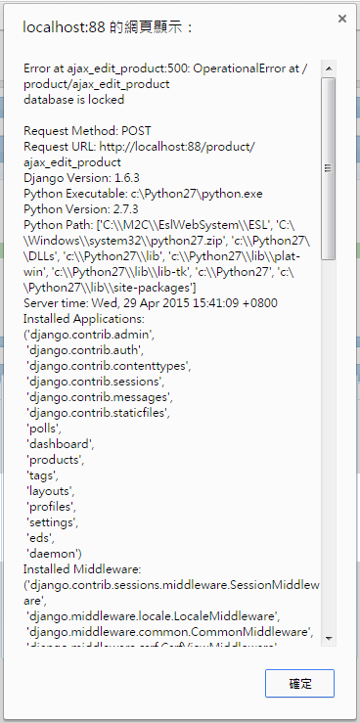

When such case happens, it is mostly like the server is busy on process the requests from the clients or daemon, and those requests are frequently accessing the database.

As the result, it is recommended to wait awhile and try again later if you see this message.

## Contact Information

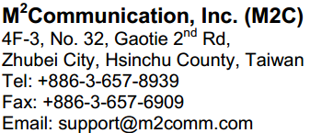

This document contains confidential information and is subject to the terms and conditions set forth in the Non-Disclosure Agreement between the Recipient Entity and M2Communication, Inc. (M2C) The information in this document is believed to be accurate in all respects at the time of publication but is subject to change without notice. M2Communication, Inc. assumes no responsibility for errors and omissions, and disclaims responsibility for any consequences resulting from the use of information included herein. Additionally, M2Communication, Inc. assumes no responsibility for the functioning of un-described features or parameters. M2Communication, Inc. reserves the right to make changes without further notice. M2Communication, Inc. makes no warranty, representation or guarantee regarding the suitability of its products for any particular purpose, nor does M2Communication, Inc. assume any liability arising out of the application or use of any product or circuit, and specifically disclaims any and all liability, including without limitation consequential or incidental damages. M2Communication, Inc. products are not designed, intended, or authorized for use in applications intended to support or sustain life, or for any other application in which the failure of the M2Communication, Inc. product could create a situation where personal injury or death may occur. Should Buyer purchase or use M2Communication, Inc. products for any such unintended or unauthorized application, Buyer shall indemnify and hold M2Communication, Inc. harmless against all claims and damages.